CHILDREN’S HANDBOOK
RYE COMMUNITY HOUSE

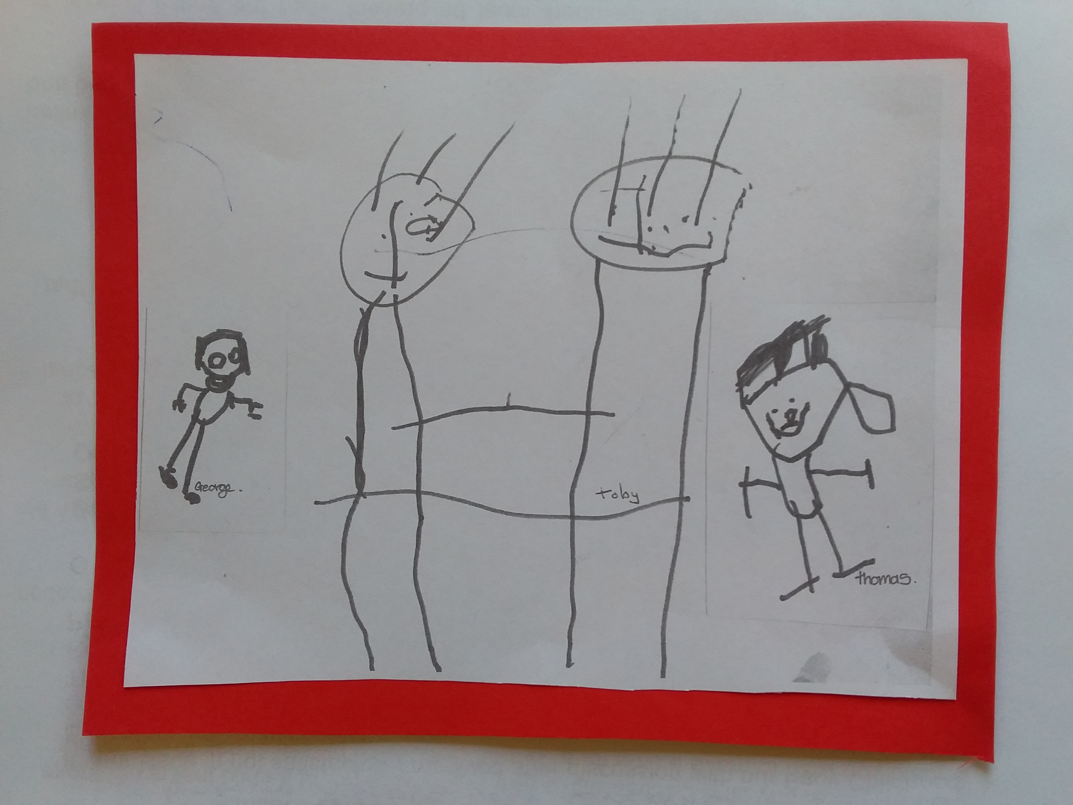

We are committed to providing children with a stimulating environment in which they are offered the opportunity to work, explore, learn and discover at their own pace.

We regard each child as unique individuals with their own interests, strengths and abilities which should be respected and valued by all.

Our goal is to ensure your child has a strong sense of identity & well-being, feeling connected to their world and with the confidence to achieve the best that they can be.

Contents

Our Aims 3

Admission and Enrolment 5

Fees and payment 6

What next 7

Providing a child safe environment 9

Communicating with families 14

Privacy and confidentiality 14

OUR AIMS

- To enable children to:
  - participate in a program of learning at their own level, but also build their esteem to strive towards the next goal
  - learn to be independent, e.g. getting dressed, toilet training,
  - learn to control self and understand consequences of their own behavior,
  - learn respect for others, take turns, etc.
  - to have fun
  - to support families in our community

We achieve our aims and fulfill our philosophy by:
- Recognising that each child is an individual.
- Providing quality developmental programs within the context that learning and play should be fun.
- Employing caring, qualified and experienced staff who can meet the varying needs of each child.
- Providing facilities of a high standard located within a healthy environment.
- Encouraging parent involvement in our program.
- Ensuring that parents have the opportunity, to discuss their child’s needs with staff.
- Providing an invaluable quality childcare service at an affordable cost.
- Encouraging children to participate in a warm, welcoming, safe environment outside their home.
- Volunteers: Including and involving volunteers within our program

EARLY CHILDHOOD EDUCATORS: DIPLOMA QUALIFIED
Coordinator – Lindy Carter
Georgia Trotter, Gina Isufi – DIPLOMA QUALIFIED
Volunteers – Katie De Jong, Marlene Smith, Jan Fletcher, Janice Miller
Relief staff- Diane Jarcola &Jess Downie - DIPLOMA QUALIFIED
All staff (not including volunteers) hold a current Level 2 Senior First Aid certificate and CPR training, Emergency asthma training and anaphylaxis management training.

HOURS OF OPERATION
Our hours of operation are:

  - 9.00am – 2.00pm Monday to Friday.
  - 9.00am – 2.00pm. Tuesdays & Wednesdays during school holidays, with the exception of four weeks during the end-of-year holidays when we are closed. We will be closing for 2019 on Friday 20 December and will re-open on Tuesday 21 January 2020.

We do not operate on weekends or on official Victoria Public Holidays.

LEADERSHIP AND STAFF EMPLOYMENT
We recognize that leadership together with the employment of appropriately qualified staff is a key contributor to the quality of program delivered and quality educational outcomes for children, ensuring the health safety and wellbeing of all children.

HOW OUR ROOM FUNCTIONS
A qualified staff member (Diploma of Early Childhood Education and Care) in consultation with the team establishes the program, which includes all the areas of development – communication, social emotional, routine/independence, fine and gross motor skills, creative and cognitive.

The assistants and volunteers are there to help with the running of the program. They help prepare the activities, interact with the children and help with cleaning.

DAILY ROUTINE (FLEXIBLE)

9.00 am Children arrive and begin indoor or outdoor play depending on the weather.

10.30am Morning Tea.

11.00am Play activities, arts and crafts.

12.15 – 12.30pm Lunch is served when children are hungry

12.45pm Rest/quiet time. Inside/outside play.

1.45pm Children assist to pack away in preparation for parents return.

2.00pm Home time.

ADMISSION AND ENROLMENT

ADMISSION CRITERIA
We accept children aged from 6 months to 5 years of age.

ORIENTATION SESSIONS
Upon enquiry you will be given all relevant forms to enable you to enrol your child.

We encourage you to visit our children’s room for an orientation session to enable staff and child to get to know each other. Subsequent visits may be arranged, if needed, before your child is enrolled.

WAITING LIST
We accept enrolments throughout the year whenever places are available.

When a place is not available for your child, we will add you to the waiting list and offer your child a place when one becomes available. If you accept the placement, we will begin the enrolment process.

Fees will apply from the time that enrolment is completed.

ENROLING YOUR CHILD
All paperwork must be properly completed and this Handbook read by a parent/guardian. The Parent/guardian Agreement which forms part of the enrolment form must be signed.

A fully completed enrolment form and an Immunisation History Statement from Medicare must be provided before a child can be left at the service. The Immunisation History Statement must:
- state that the child’s immunisations are up-to-date.
- state the child’s next immunisation due date(s).
If a child’s next immunisations are due prior to the commencement of care in our service, an updated Immunisation History Statement may be required.

Policies and procedures for the operation of our service are available on request

Parents should notify the children’s co-coordinator and the office of any changes of details on the enrolment form.

For each subsequent school term of that same year, each child will retain their place unless otherwise notified.

We require two weeks written notice to cancel your child’s booking

RE-ENROLMENT
Re-enrolments for the following year will take place in the last term of each year, when all currently-enrolled families and families on our waiting list are given a new enrolment form to complete for the following year.

Places will then be allocated on a ‘first come, first served’ basis. Families will be required to pay a $10.00 Rye Community house membership each year.

FEES AND PAYMENT

Our fees are set in line with the Child Care Subsidy managed by the Federal Government. The rate is $11.77 per hour. We do not charge for public holidays.

Out-of-pocket fees must be paid fortnightly. Unpaid fees may result in cancellation of your child’s enrollment. If you are having difficulties paying your fee contribution you need to make an appointment with our office to arrange a payment plan which must be adhered to.

Fees will not be reimbursed and ‘catch-up’ or ‘make-up’ sessions will not be applied if your child does not attend our service for any reason, including illness, on any days of booked care. This is in line with most other childcare services’ fees policies.

Annual Membership fee: $10.00 per family - payable with the first term fees or upon starting children’s program. The membership covers the parent.

Materials Levy fee: $30.00 per child to cover extras the children make e.g. Mother’s Day, Father’s Day.

WHAT NEXT:

WHAT YOUR CHILD WILL NEED TO BRING EACH DAY

- All children need a NAMED BAG for their belongings.
- Food for morning tea and lunch in a named container.
- CLOTHING
  - A full change of clothes.
  - Dress children in weather-appropriate clothing suitable for indoor and outdoor play.
  - In warm weather, clothing that will cover the child’s shoulders and back.
  - Sunhat from September to April (inclusive).
- FOOTWEAR
  - It is better for children’s developing feet muscles, for children to go barefoot. If a child wishes to remove their shoes, we will allow them to do so inside and outside unless you have requested otherwise.
  - We discourage flip-flops, crocs and gumboots as flip-flops are unsafe and gumboots can cause fungal infections. If gumboots are worn, slippers or shoes for inside should be provided in your child’s bag as an alternative to wearing gumboots for extended periods. Alternatively, your child may go barefoot.

- INFANT NEEDS
  - Several disposable nappies
  - Clearly named bottles with caps plus 1 empty bottles,
  - Clearly named dummy (in a named container) if normally used.
  - Security blanket/toy if normally used.

HELPING YOUR CHILD SETTLE IN

Most children will experience some anxiety when saying goodbye, especially the first few times.

Ways of preparing your child;
- Talk about the room and possible activities, who they will see etc.
- Allow time to stay and watch as your child settles in.
- Set up some arrival routines, sign in, put belongings away together, kiss and cuddle goodbye, saying when you will return/who will pick up.
- Greet staff members together to show your child that you know them.
- Be firm but caring about leaving.
- Staff will assist if necessary.

LATE PICK-UP PROCEDURE

We understand that sometimes you may be unable to arrive on time to collect your child.

In this instance, we ask that you ring the Children’s Room on 5985 9340 and advise the staff as soon as possible when you know you will be late and the approximate time of your arrival. This allows us to reassure your child.

The attendance sheet at the reception to the room will be completed by a staff member and the parent will need to sign the sheet at the time of collection.

$5 after 5 minutes up to 15 minutes per child, then $10 for every 15 minutes after that or part thereof. If you are going to be late please call 5985 9340.
ARRIVAL AND COLLECTION
Upon a child’s arrival and departure, an accompanying adult must sign the attendance book in the foyer and enter the correct arrival and departure time.

If someone other than a parent/guardian is collecting a child at the end of a session the person who is bringing the child at the commencement of the session, must write down in the attendance book the name of the person who will be collecting the child that day. The person collecting the child must be authorised to do so on the child’s enrolment form. If a non-authorised person is collecting the child, the procedure for ‘Authorisation Process for a Change in Person Collecting the Child’ must be followed. See further below for more information on this procedure.

If an emergency arises and the notified person is unable to collect your child, we must be contacted and told who will be picking them up.
Please read our Delivery and Collection of Children policy for more information.
Please sign the medication book upon arrival and departure if your child requires medication. Don’t forget to collect the medication when you leave.
If you will not be contactable on your normal contact number on any day, please note this in the attendance book.
Please speak to staff with any relevant details concerning your child e.g.: your child is on medication, exciting happenings, behavioural issues, etc.

UPON ARRIVAL AND DEPARTURE PLEASE ENSURE THAT ALL DOORS AND GATES ARE CLOSED PROPERLY. PLEASE BE VIGILANT – DO NOT LET A CHILD THROUGH A GATE OR DOOR OR INTO THE PARKING AREA WITHOUT THE CHILD BEING ACCOMPANIED BY A RESPONSIBLE ADULT.

PROVIDING A CHILD SAFE ENVIRONMENT

AUTHORISATION PROCESS FOR A CHANGE IN PERSON COLLECTING THE CHILD

We recognize that from time to time circumstances are beyond your control occur and that a parent/guardian/authorised person is unable to collect a child on time. In this event the following process will be followed:

The parent MUST notify Children’s Room staff by phone call to inform them of the situation.

The parent must provide the name, surname, contact phone number and residential address of the non-authorised person who will be collecting the child.

The parent MUST inform the non-authorised person that they will need to provide proof of identification to a staff member when they arrive to collect the child. This can be either a current Australian driver’s license or a current passport. The staff member will verify the identity of the non-authorised person.

If the non-authorised person’s identity is verified, the child will be released into the care of the new nominated person. A parent will subsequently be required to complete a Collection Authorisation form on their next visit.

If there is a discrepancy in any of the information, the child WILL NOT be released into the care of the non-authorised person. Staff will contact the parents and inform them of this. The child will remain in care until the parent/guardian can collect the child. Late collection procedures and late fees will apply from here on.

Please read our Delivery and Collection of Children policy for more information.

SAFETY REGULATIONS

There are some safety regulations which help us to provide a safe environment for your children. Please help your child understand why we have these rules:

- We ask that children do not climb fences or gates.
- We encourage the children to walk, not run, when inside.
- Equipment and sand will not be thrown.
- Children will be asked to sit when eating and drinking.
- Children are not permitted in the rest of the building, unless accompanied by a childcare staff member or parent/guardian.

SUN SAFETY

From August to April, anytime the sun’s UV level is 3 or higher according to the SunSmart App:
- We encourage children to wear sun-safe hats that protect their face, neck and ears. Sun-safe hats include: bucket hats with a deep crown and brim of at least 5cm (adults 6cm), broad-brimmed hats with a brim size of at least 6cm (adults 7.5cm).
- We apply SPF 50+ sunscreen to the children’s skin.
- When outside, children who do not have appropriate hat or clothing or who refuse to them are asked to play in the shade.

If you prefer that your child wears their own sunscreen please provide it in its original container with your child’s name clearly labelled on it and hand it to a staff member upon your child’s arrival. If you wish for it to be returned at the end of the session please inform staff, otherwise it will be kept for future use, exclusively for your child.

Children are encouraged to be sun smart. They will be encouraged to wear a hat outside. Sunscreen should be applied to children by their parents/guardians before or upon arrival at our service from November to April inclusive. Outside of those times, staff will monitor the sun’s UV levels and will apply sunscreen as needed when UV levels reach 3 or above according to the SunSmart app.

IMMUNISATION

No jab, no play policy. In keep with the Federal and State Governments’ ‘NO jab, no play’ policies, children MUST have acceptable proof of immunization prior to enrolment in the form of an Immunisation History Statement from Medicare. We are not legally able to accept any other form of proof of immunization.

MEDICAL MANAGEMENT PLANS

In the management of medical conditions parents are required to provide a medical management plan if an enrolled child has a specific on-going health care need(s), allergy or relevant medical condition.

A risk minimisation plan and a communication plan are then developed by the Childcare Coordinator in consultation with the child’s parents/guardians.

All staff members, students and volunteers of the childcare room are informed about the practices to be followed.

Where a child that is enrolled at the service has a specific health care need, allergy or other relevant medical condition, parents/guardians are provided with a copy of the risk minimisation plan, communication plan and relevant policies.

Medication and medical procedures can only be administered to a child with written authorisation from the parent/guardian or a person named in the child's enrolment record as legally authorised to consent to administration of medication (Regulation 92(3)(b)).

Staff may need additional information from a medical practitioner if the child requires multiple medications simultaneously or if a specific medical procedure must be followed.

MEDICATIONS

Medication will only be administered to a child if a medication administration form as been completed and signed by a parent/guardian of the child each day the medication is required.

Medication must be handed directly to a staff member upon your child’s arrival.

Staff will accurately detail the dosage that was given to the child, the time and the date it was given, the name and signature of the person who administrated the medication and the name & signature of the person who checked the dosage & administration.

A parent/guardian of the child will then need to sign the form again upon collecting their child, if the medication was administered by staff.

ALLERGIES AND ANAPHYLAXIS

In the event that any child with anaphylaxis risk attends our service, any products that may cause them to suffer anaphylactic shock will be discouraged from our service. This may include certain foods, chemicals, perfumes, materials etc. Families will be informed and we will endeavor to minimize the risk of exposure.

Any children who are at risk of anaphylaxis will need an anaphylaxis action plan completed by a doctor before their enrolment can be completed. They will also need an Epi-pen to be kept in our service.

Please read our Anaphylaxis and Allergy policy for more information.

ILLNESSES AND INFECTIOUS DISEASES

Our Illness Policy has been established to protect all children and staff from cross infection.

The wellbeing of each child is of the highest priority at our centre. It is best for your child and other children at our centre if you keep your child home if they are unwell. We ask parents/guardians to respect the welfare of the other children and staff who are attending the program.

The Childcare Coordinator should be notified immediately if your child has an infectious disease for which your child must be excluded from care and/or a notifiable disease.

If a child is diagnosed with a notifiable disease, the House will report this to the Department of Education and Training and members of the centre will be notified by letter.

Children may not attend the program if they have any of the following:
- Sore throat, difficulty swallowing
- Eye redness or discharge
- Blood in urine or faeces
- Vomiting or diarrhea in the previous 24 hours.
- Reaction to immunisation
- Been less than 24 hours since starting antibiotics (for antibiotics to start working as well as in case of reaction to medication)
- Head lice
- Fever – temperature > 38 degrees
- Unusual rash without a clearance certificate from a doctor
- Headache
- Stiff neck
- Severe, persistent or prolonged coughing
- Difficulty breathing
- Infectious excludable disease
- Notifiable disease

If any of the above are detected during a session the parent or guardian will be contacted to come and collect the child. If they cannot be contacted the emergency contacts on the enrolment form will be contacted. The exclusion from the program will be until treatment has begun and the condition has cleared and/or the applicable exclusion period has been completed.

If the child becomes ill during a session they will be made comfortable away from the other children until they can be collected.

Please do not give your sick child Panadol/Nurofen or other medication to mask their symptoms and then bring them into our care. The best place for a sick child is at home with you.

Fees will not be reimbursed and ‘catch-up’ or ‘make-up’ session will not be applied if your child does not attend our service due to illness.

Please read our complete Injury, Incident, Trauma and Illness policy for more information.

ACCIDENTS

In the event of an accident or minor injury to a child, the childcare co-coordinator will render immediate assistance and assess the situation.

In the case of minor abrasions, a staff member will wash the wound. The child will be rested in a quiet area of the children’s room, supervised by a staff member until the child feels they are ready to rejoin the group.
If the child’s condition seems more serious, the childcare coordinator will stay with the child and a staff member will alert the House Manager and take charge of the remaining children.

The House Manager will render assistance, assess the situation and if necessary call an ambulance and the child’s parent or guardian.

If necessary the child will be moved to a quiet area and made comfortable.

In all cases of accident or injury, details will be entered into the accident book and the parent or guardian must sign and date it, to accept that they have an account of the event.
If the child’s parent or guardian cannot be contacted, emergency contacts from the enrolment form will be contacted.

Parents or guardians are to meet all ambulance or medical costs involved.

Please read our Incident, Injury, Trauma and Illness policy for more information.

CHILD PROTECTION
The Community Care Division of the Victoria Governments’ Department of Human Services has a publication, Protocol between Child Protection and Children’s Services (2004), that details the requirements and procedures for managing reports and suspicions of child abuse in a children’s service. Child protection policy is based on the principle of partnership and shared responsibility across a broad range of human service professionals, including schools and licensed children’s services. Licensed children’s services and Victoria schools play an important role in the prevention of child abuse and neglect through their access to information about family functioning and the needs of children. When a staff member forms a belief that a child has been harmed or is at risk of being harmed, they must take action that is timely, respectful and co-ordinated.

Please read our Commitment to Child Safety Statement for more information.

OUR BEHAVIOUR GUIDELINES

At all times staff will encourage positive behaviour habits using positive reinforcement, praising a child for sharing, taking turns, helping other children, being friendly and respecting people and property.

Please refer to our Behaviour Guidance and Management policy for more details.

HEALTH

The staff at our House will at-all-times promote healthy attitudes towards food, personal hygiene and the environment within which we live.

We ask that parents do not include snacks that contain nuts or nut products.

Sweet foods are discouraged, except for fruit and fruit-flavoured yogurt.

EMERGENCY PROCEDURES

The Emergency and Evacuation Plan is displayed at all exits. Please familiarise yourself with this plan. We also encourage you to read our Emergency Procedures policy.

FIRST AID

All staff (not including volunteers) hold a current Level 2 First Aid certificate and CPR training, Emergency asthma training and anaphylaxis management training. An appropriately stocked first aid kit is clearly marked and can be found in the children’s room.

COMMUNICATION WITH FAMILIES
Parents are encouraged to communicate regularly with the Children’s Coordinator or other staff members.
There is also a parent’s communication book in the children’s room.
Staff will not at any time discuss with a parent the behavior of a child that is not theirs.
Should you wish to make a time for a ‘longer’ discussion please speak to one of our staff for advice.

PRIVACY AND CONFIDENTIALITY

We recognise and respect the right to privacy and the protection of personal information for everyone that is associated with the House (staff, parents and children alike).

We are committed to protecting your right to privacy and confidentiality and we abide by the National Privacy principles governing the use and release of personal information with integrity.

Parents are encouraged to communicate regularly with the Children’s Coordinator or other staff members, any concerns can be discussed at this time. For a more personal discussion, please ask the House Manager for an interview time.

Staff will not at any time discuss with a parent the progress or behaviour of a child that is not theirs.

LEGISLATION AND REGULATIONS

Our service is registered with the Department of Education and Training as a Limited Hours Type 2 Licensed service and must abide by the Children’s Services Act 1996 and Children’s Services Regulations 2009.

Two approved, qualified staff members must be present when the house is open to receive children.

The license of the Children’s Services is in a prominent position at the entrance of the Children’s Room as are:
- The name(s) of Primary Nominee(s) and the Nominee(s).
- Hours of operation.
- An outline of the program for the children is displayed.
- The name, address and phone number of the responsible officer of the Department is displayed.

Information stated under Regulation 41 of the Children’s Services Regulations 2009, is available for inspection at-all-times.

COMPLAINTS, FEEDBACK OR COMPLIMENTS

For concerns about Rye Kidz Program, please speak to the House Manager or
phone Rye Community House on 59854462 to make a time to discuss your concerns.

If your issue in not satisfactorily resolved after discussion with our Early Childhood Educators, you may contact:

The Board of Governance President
Rye Community House
P.O. Box 237 Rye Vic 3941
Or
Department of Education and Training
Service Administration and Support Unit
On 1300 307 415 or email licensed.childrens.services@edumail.vic.gov.au

ABOUT RYE COMMUNITY HOUSE

MISSION STATEMENT
To be an inspirational place for connection through social interaction, supporting growth and development across all ages.

OUR VISION
Our Community House – A place for all people.

Rye Community House and Rye Beach Kidz, volunteers, and Board of Governance hope you and your children enjoy your time at the house.

There is a copy of the Children’s Services Act (1996) and Regulations (2009) in the children’s room for your perusal.
Our business models in line with funding arrangements set by the Federal Government program Child Care Subsidy. Operating 48 weeks per year.

PARENT AGREEMENT

Please sign and return this form to a staff member of Rye Beach Kidz.

I have read and understand the Parent Handbook and I agree to be bound by its contents and the policies and procedures of Rye Beach Kidz.

Name of Parent: ___________________________________

Signature of Parent: _______________________________

Date: ___________________________________________

