**Rye Community House**

**27 Nelson St Rye. 5985 4462**

**Courses & Activities**

**Term 1, 2019**

**January 29 – April 5**

*

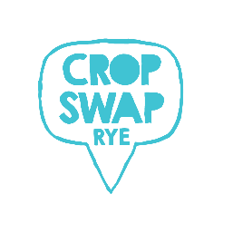



Life is a puzzle, find your missing piece.

Find a fun and adventurous experience here.

*Give us a go.*

*ABN: 68 360 898 929*

[*ryecommunityhouse@gmail.com*](mailto:ryecommunityhouse@gmail.com)

[*www.ryech.org*](http://www.ryech.org)

[](https://www.facebook.com/ryecommunityhouse/)

|  |
| --- |
| Rye Kidz |

Rye Kidz is a type 2 licenced childcare service located within the Rye Community House. We offer occasional care and a 3yr old program, both of which are very popular. The location and function of the childcare centre provides for a close connection of early childhood learning experiences for young children, being close to the Rye kinder and the local Rye primary school.

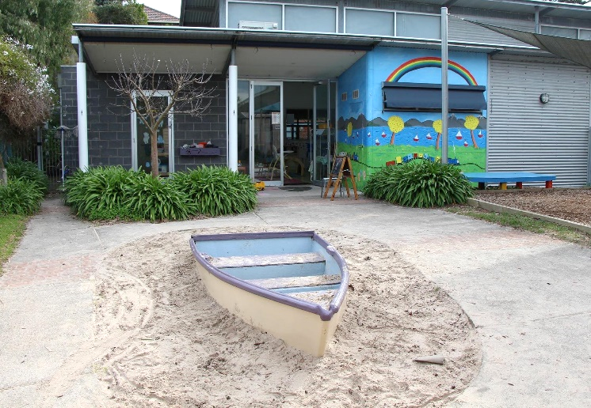

|  |  |  |  |  |  |  |  |
| --- | --- | --- | --- | --- | --- | --- | --- |
| **Take-a-Break** | |  | | |  |  | |
| Monday | 9am | | - | 2pm | | |
| Tuesday | 9am | | - | 2pm | | |
| Wednesday | 9am | | - | 2pm | | |
| Thursday | 9am | | - | 2pm | | |
| Friday | 9am | | - | 2pm | | |

For all childcare enquiries or bookings for your child please pop in and have a chat with our childcare team or phone directly on 5985 9340.

**Contact Rye Kidz**

Phone 5985 9340

Email: [ryebeachkidz@gmail.com](mailto:ryebeachkidz@gmail.com)

We are a registered charity and all donations over $2.00 are tax deductible.

|  |
| --- |
| Monday |

**Rye Kidz Playgroup Dates: February 4 – April 1**

**Time: 9.30am – 11.30am Cost: $5.00 per family per week**

A facilitated playgroup for mums, dads or grandparents to spend time in play with the children. Great activities, lots of fun. Bookings essential.

**Rye readers book club Dates: 2nd Mon. of the month**

**Time: 10.00am - 12.00midday Cost: $3.00 per class**

Social gathering to read and discuss the book of the month. Must be a Mornington Peninsula library member.

**The Garden Party Dates: February 4 – April 1**

**Time: 11.00am – 12.00midday Cost: FREE**

Community Gardening in the Grow and Play Gardens in Lyons Street is where the gang all meet. Won’t you join us and get your hands into the earth. We have guest speakers, planting days, sharing stories and tips.

**From Basic to Brilliant Dates: February 18 – March 25**

**Time: 12.00 – 2.00pm Cost: FREE**

We supply everything you need to make a nutritional, tasty and quick meal that the whole family would enjoy. Covering soups, mains and desserts.

**Easter Lunch Dates: April 1**

**Time: 12.00 midday Cost: $10 per head**

No it’s not an April fools joke, there really will be a lunch to celebrate Easter. Prepared by the basic to brilliant cooks. Great meal planned, two courses.

**Be Connected - IT club Dates: February 4 – April 2**

**Time: 12.00pm - 2.00pm Cost: FREE**

Free computer classes for the over 50’s. This is a government initiative to get every Australian online. Digital connections and social connections.

**Great art expectations Dates: February 4 – April 1**

**Time: 12.30pm - 3.30pm Cost: $50 per term**

This art class welcomes all levels and explores all mediums, including acrylics, pastels & oils guided by our talented tutor. Class is full, register for waiting list.

**Patchwork aplenty Fortnightly commencing Feb 4**

**Time: 7.00pm - 9.00pm Cost: $27 per class per week**

Join a group of ladies who are learning patchwork and quilting techniques.

All levels are welcome.

|  |
| --- |
| Tuesday |

**Patchwork aplenty All year – Commencing January 29**

**Time: 9.30am - 11.30am Cost: $27 per class per week**

Join a group of ladies who are learning patchwork and quilting techniques. All levels are welcome*.*

**Yoga with Laura**

**Time: 10.00am - 11.00am Ph: 5986 5207**

A great one for beginners, gentle, focuses on your breathing and wellbeing

**Grandparents make everything better Dates: February 19**

**Time: 10.00am – 11.00am Cost: FREE**

Join us for this info session. We invite grandparents and parents. Many grandparents and grandchildren are separated by distance or other circumstances and missing out on the grandparent/grandchild connection. Work with us in bridging that gap. Register your interest. Morning tea provided.

**Be Connected - IT club Dates: January 29 – April 2**

**Time: 12.00pm - 2.00pm Cost: FREE**

Free computer classes for the over 50’s. This is a government initiative to get every Australian online. Digital connections and social connections.

**Pencils at the ready Dates: February 29 – April 2**

**Time: 1.00pm – 3.00pm Cost: $5 per class**

Social drawing that is run by the group for the group. Each week someone chooses a subject to draw. If you have a little more experience than a beginner this class is for you.

**French – Basic level Dates: February 29 – April 2**

**Time: 4.00pm - 6.00pm Cost: $110 per term**

For beginners wanting to learn conversational style French.

**Hatha yoga with Annie**

**Time: 6.15pm - 7.15pm Ph: 0414 599 455**

BYO Mat and stretch and strengthen your way to a healthy body.

**New services we proud to offer**

**Massage on Monday mornings with Briony** – Phone 0408 995 670 to book an appointment. Relaxation and Deep Tissue, fully qualified.

**Sewing machine and Overlocker servicing** - drop off and pick up on Tuesday mornings before 11.30am, here at the Community House

**Satellite Wig Salon-** For ladies experiencing hair loss. Appointment required.

Phone Kate 0407 525 119.

|  |
| --- |
| Wednesday |

**Walk for a good life School term only commencing Feb 7**

**Time: 9.00am - 10.30am Cost: FREE**

Meet here at the House. Partnering with the Heart Foundation we invite you all for a great walk around our beautiful township and beyond. Looking for volunteer leaders, would you be one?

**The chatty crafters School Term only**

**Time: 9.00am - 11.30am Cost: $5 per class per week**

Self-guided group explore fun techniques and different crafts, while enjoying the company of like-minded crafties.

**Family Tree on Pt Nepean Dates: All year commencing Jan 30**

**Time: Beg: 11.00am – 1.00pm Adv: 1.30pm – 3.30pm Cost: Beg $10 Adv $5**

Discover more about your family history in a social environment where everyone has a story to research and share.

**Men in the kitchen School Term only**

**Time: 11.30am - 3.30pm Cost: $25-$35 depends on the meal**

A social men's cooking group that gather to create meals with flavours and techniques to tempt the tastebuds. Class is full, register for waiting list

**Drawing for beginners Dates: January 30 – April 3**

**Time: 12.00midday - 2.00pm Cost: $10 per class per week**

With just a pencil and paper you can learn to draw brilliantly in this structured class with our talented tutor.

**Card and Board Games Dates: February 6 – April 3**

**Time: 2.30pm – 5.00pm Cost: $3 per person per week**

Play for fun, learn new games with your fellow players or teach others what you know. Share for social interaction. We supply card tables and chairs and some packs of cards.

**Sewing Bee for Boomerang Bags Dates: School term only**

**Time: 6.00pm – 9.00pm Cost: FREE**

Gather volunteers, get together to make bags for the wider community, and make a difference for our environment. There is a job for everyone from cutting, ironing and sewing. BYO sewing machine.

|  |
| --- |
| Thursday |

**Awash with watercolours Dates: January 31 – April 4**

**Time: 9.30am - 12.00mid Cost: $145 per term**

Get creative with watercolours. Bring out the artist within, in this

fun-filled class. Class is full, register for waiting list

**Rye Beach Bridge Club Dates: All year**

**Time: 10.00am – 12.00pm supervised. Duplicate 1.00pm – 4.15pm**

**Phone Margaret 0418845753 or Brian 0439845753**

You can learn techniques in the morning then put your skills to the test for the afternoon.

**Knit one – Purl One Dates: January 31 – April 4**

**Time: 12.00pm – 2.00pm Cost: $3.00**

A social group for ladies who love to knit, want to learn, want to knit for a community effort and would enjoy teaching and learning off each other. BYO knitting needles, we do have some donated wool here. We knit for a good cause.

**Sewing Bee for Boomerang Bags Dates: January 31 – April 4**

**Time: 1.00pm – 3.30pm Cost: FREE**

Gather volunteers, get together to make bags for the wider community, and who want to make a difference for our environment. There is a job for everyone from cutting, ironing and sewing. BYO sewing machine.

**French – Next Level Dates: January 31 – April 4**

**Time: 4.00pm - 6.00pm Cost: $110 per term**

This class is for those who already have knowledge of the French language.

**Guided Meditation Dates: School term only**

**Time: 7.30pm – 9.00pm Ph: Michelle 0450 644 182**

Great stress relief and calming influences through a guided meditation and beautiful space.

**SAVE the DATE Won’t you join us, its going to be a blast!**

Holistic on Rye Saturday January 5, 10.00am – 4.00pm Seaside Scavenge Sunday January 13 10.00am – 2.00pm

Billy Cart Derby Saturday March 16, 2019 9.00am – 4.00pm

Ask us at Reception for a flyer with further information.

One off Workshops and Events

Saturday One-off Workshops and Events

|  |
| --- |
| Friday |

**Mixed Mediums Dates: February 1 – April 5**

**Time: 10.00am - 12.30pm Cost: $145 per term**

Bring out the artist within, in this fun-filled class. With full guidance from the tutor you can explore different art mediums.

**Pilates Dates: February 1 – April 5**

**Time: 11.15am – 12.15pm Cost: FREE**

Form and correct exercise mindfulness of connecting. All welcome.

**Fit beyond 50 Dates: February 1 – April 5**

**Time: 12.30pm – 1.30pm Cost: FREE**

Strength training for everyone. Form and correct exercise mindfulness of connecting.

**Knots n Natter Macramé Dates: February 22 – March 22**

**Time: 10.00am – 12.30pm Cost: $20 per class plus $10 materials.**

Macramé is back! Learn this beautiful, ancient craft. Absolute beginners or those reviving their 70’s skills all welcome.

|  |
| --- |
| Saturday |



[This Photo](http://commons.wikimedia.org/wiki/File:Golden_star.svg) by Unknown Author is licensed under [CC BY-SA](https://creativecommons.org/licenses/by-sa/3.0/)

**See our Save the Date notice on Thursdays page, for events**

**Workshops in Acrylic Dates: Feb 9, 23, March 2, 16**

**Time: 10.00am – 2.00pm Cost: $50 each workshop**

BYO materials – Easy to follow step by step guidance with demo, no experience required, suit all levels. Individual expression is encouraged and techniques explained.

|  |
| --- |
| Sunday |

**Expression of Interest RyeMakery Pop up workshops**

Repair or upcycle rather than throw out We offer workshops to teach basic skills in painting, upholstery, repairs of furniture through to maintenance around the home..

In partnership with Rosebud/Rye Rotary, we can supply you furniture for a project or bring your own.

**Register your interest**

**Sustainable Sunday Dates: 3rd Sunday of the month**

**Starts February 2019**

**Time: 2.00pm – 5.00pm Cost: FREE**

Boomerang Bags, Crop and Swap and Repair Café all under the one roof. Looking after our environment, our health and our way of life.

**Award winning program – Tidy Towns 2018.**

|  |
| --- |
| **Partnerships, Community and Networking** |

We proudly contribute to the community

|  |
| --- |
| Rye Alliance Rye Historical Society Rye Lions  Advance Community College Bunnings Rosebud Woolworths Rye  Community Houses on the Mornington Peninsula Rye P.S.  Blairgowrie Community Garden Rye Pre-school  Rye Hotel YPA Rye S & L Real Estate    The Only Butt Campaign Community Grow and Play Gardens  Southern Peninsula Social Network Community share lunch  **Ask us how to be involved….** |
| **Enrolments – Terms and conditions** | |

|  |
| --- |
| **Our Community Development** |

**Par, Community and Networking**

Bookings are essential for all activities. Enrolments can be made in person or over the phone during office hours. Monday – Friday 9.00am – 3.30pm.

Courses must be paid for when enrolling to secure your place. Fees are payable by term unless otherwise stated on the brochure. If you need to make arrangements for payment, see us confidentially in the office.

Due to the course structures the fees are set for the term. Refund exemptions for participants who have long absences due to unforeseen circumstances will be reviewed on a case by case basis. If this applies to you please contact the House Manager.

If a course is cancelled, all efforts will be made to contact you. A full refund will be given. If you wish to cancel your enrolment, seven days notice is required, or a $25 admin fee will apply. Membership is $10 per annum payable by everyone who takes part in our House activities.

Courses can be paid for in Cash, EFTpos or by cheque or by direct deposit to:

Rye Community House - Account Details: BSB: 633 108 - Account: 1129 09999

Please phone us to ensure there is a place available in the class before payment via direct deposit. Please put as much information in the payee details. Please notify us that payment has been made to ensure fees are receipted. Enrolment forms can be downloaded from our website [*www.ryech.org/downloads*](http://www.ryech.org/downloads)

**For feedback, complaints or compliments regarding our services you can download a form on our website or ask for a form from the office. All information is confidential**